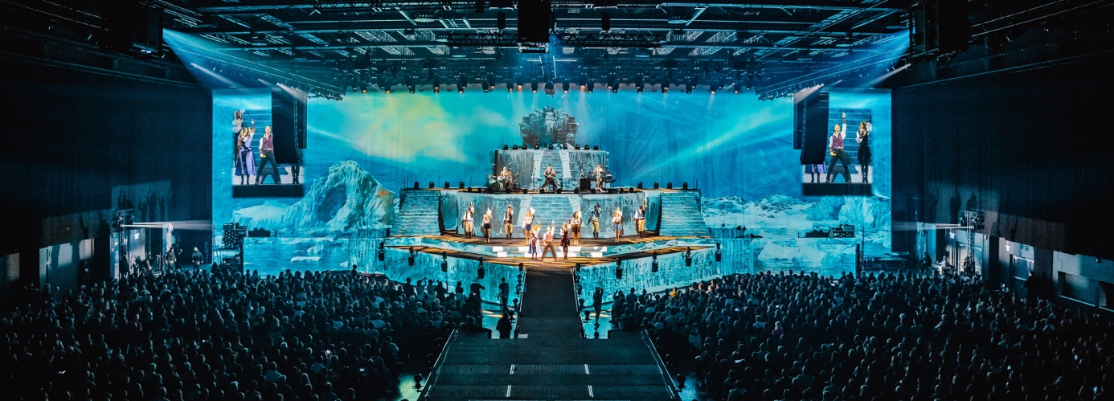
Photo credit: JulianHukePhotography, courtesy of GLP

DJ BoBo premiers “The Great Adventure”
New tour commences in May – with Sennheiser Spectera

Wedemark, March 2026 – Swiss singer and producer DJ BoBo is back with a spectacular new tour: “The Great Adventure” will take him to 28 European cities from 1 May. It has become a tradition for DJ BoBo to premier a new show with sell-out gigs at Europa-Park Rust a few months before the actual tour start, and 2026 was no exception. In Rust, his technical crew – Andre Mussong (FoH), Benni Mengler (monitors) and Jens Bublitz (backline) – put Sennheiser’s bidirectional Spectera wideband system through its paces.

DJ BoBo’s tech team had first learnt about Spectera via their Sennheiser contact Chris Kopp, as Andre Mussong recalls, and the rehearsals for the upcoming tour in Rust were the ideal opportunity to switch to Spectera as an in-ear system. Benni Mengler was immediately struck by the fast set-up and frequency coordination, and then by the excellent audio quality.

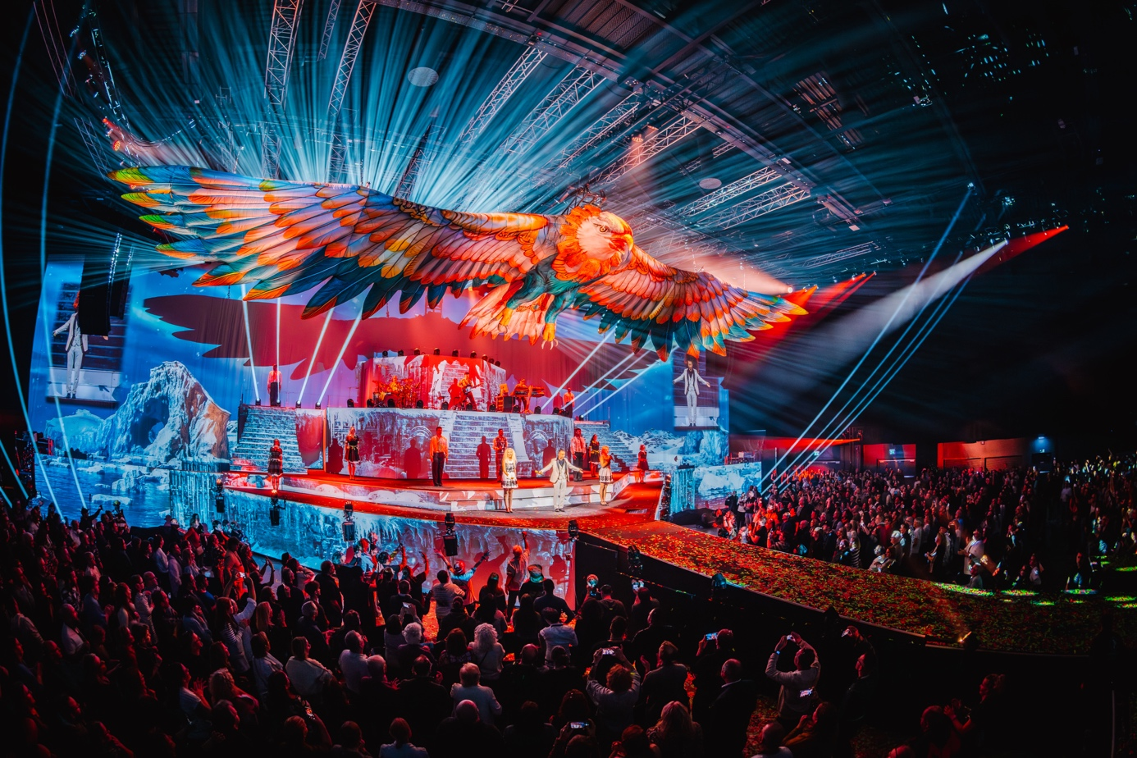 | DJ BoBo’s spectacular “The Great Adventure” show premiered in Rust and will tour from 1 May 2026  (Photo credit: JulianHukePhotography, courtesy of GLP)

Mengler explains: “Everyone on stage uses Spectera SEKs – dancers, gymnasts, singers and band. We are running 26 Spectera SEKs as IEM receivers, and one additional SEK as a line transmitter for the acoustic guitar, which is used during two songs.”

Dancers were equipped with Spectera SEKs and IE 100 PRO in-ear phones  (Photo credit: Yes Music / Studio Boregard) | 

Jens Bublitz adds that with the previous guitar transmitter, the guitarist lost connection when on B stage, so they simply used an additional SEK bodypack as instrument transmitter. “Spectera performs so much better in terms of RF signal transmission. I also couldn’t notice any deterioration in sound quality – quite the contrary,” Bublitz smiles.

To cover the wide A and B stages, the IEM set-up includes three DAD antennas, one in monitor world on stage left, one on stage right near the band, and one on the B stage.

Spectera DAD transceiving antenna near the drum kit  (Photo credit: Yes Music / Studio Boregard) | 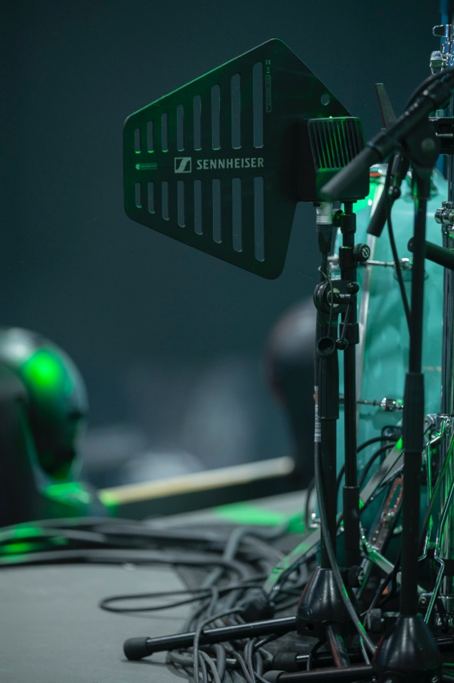

All in one wideband channel
Mengler runs a total of 12 stereo IEM mixes (plus the mic for the acoustic guitar) via MADI 96 kHz in one wideband channel with a centre frequency of 490 MHz. He uses “Live Low Latency” mode for the band and singers, while dancers and crew are on “Live” mode. “That’s all in one RF wideband channel of 8 MHz, so we are exploiting the Base Station 100%.”

DJ BoBo performed with his custom gold-plated SKM 2000 and a Spectera SEK used as IEM receiver
(Photo credit: JulianHukePhotography, courtesy of GLP)

When asked how Spectera had changed the way he sets up monitor world, Mengler says: “The most important thing for me is the fast way to scan, set the centre frequency and then all SEKs get into the new set-up just by switching them on. There’s no need for an infrared synchronisation, and the Spectera WebUI is very clearly laid out.”

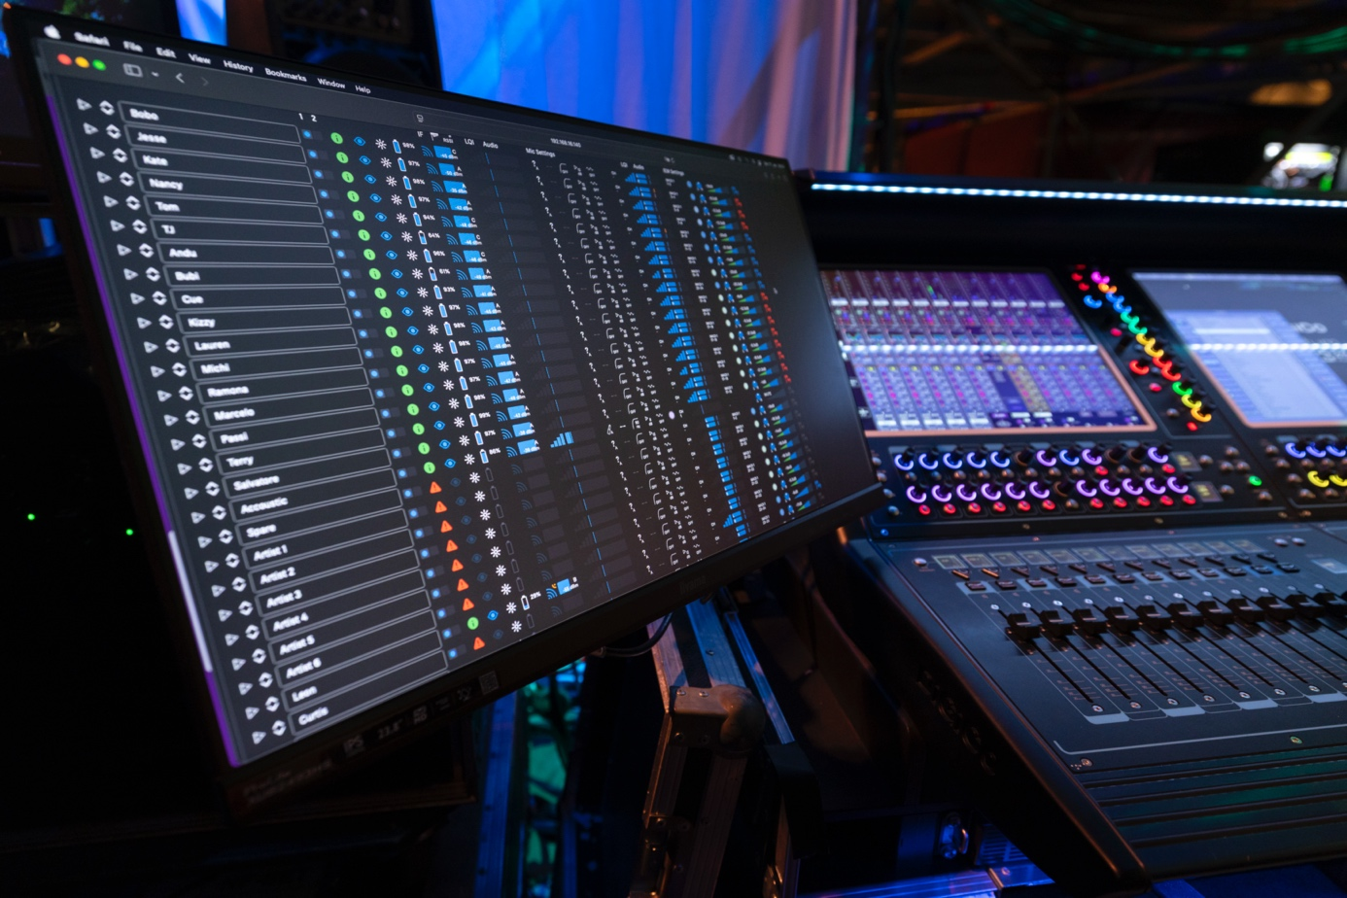 | Spectera WebUI  (Photo credit: Yes Music / Studio Boregard)

Mengler paid special attention to keeping some distance between their new digital and old analogue equipment. “We use analogue SKM 2000 handhelds, some of them customized. When you have them too close to digital transmitters, noise can occur in the analogue receiver. So we made sure the digital SEKs were worn across from the hand holding the mic, or on the artist’s back to avoid any coupling of interference noise into the analogue mic.”

“A relaxed feeling”
Mengler adds that “the entire band and crew still felt totally relaxed even after several hours of listening via in-ears. This is one of the main differences that we found with Spectera. We tried different modes to figure out which sounded best for our requirements, and everyone is really happy with the sound. We have combined Spectera with a KLANG immersive IEM processor, and that has opened a new world of listening. For the band, Spectera meant a world of difference, which is why the production invested in Spectera in the first place.”

Bublitz remarks: “As the backliner on the side position, I found the Spectera sound very pleasant, without the dropouts or ‘noise’ that occurred from time to time with our analogue gear. This allowed me to concentrate much better on the musicians’ tracks.”

For ambience, Mengler uses two different mics on each side of the stage, a shotgun for narrow signal capture and a cardioid Sennheiser MKH 40 for wider pickup.

The drumkit was fitted with an e 901 for the bass drum, four MD 421 for toms, two e 905 on snares, one e 914 on hi-hat, and two MK 4 as overheads.

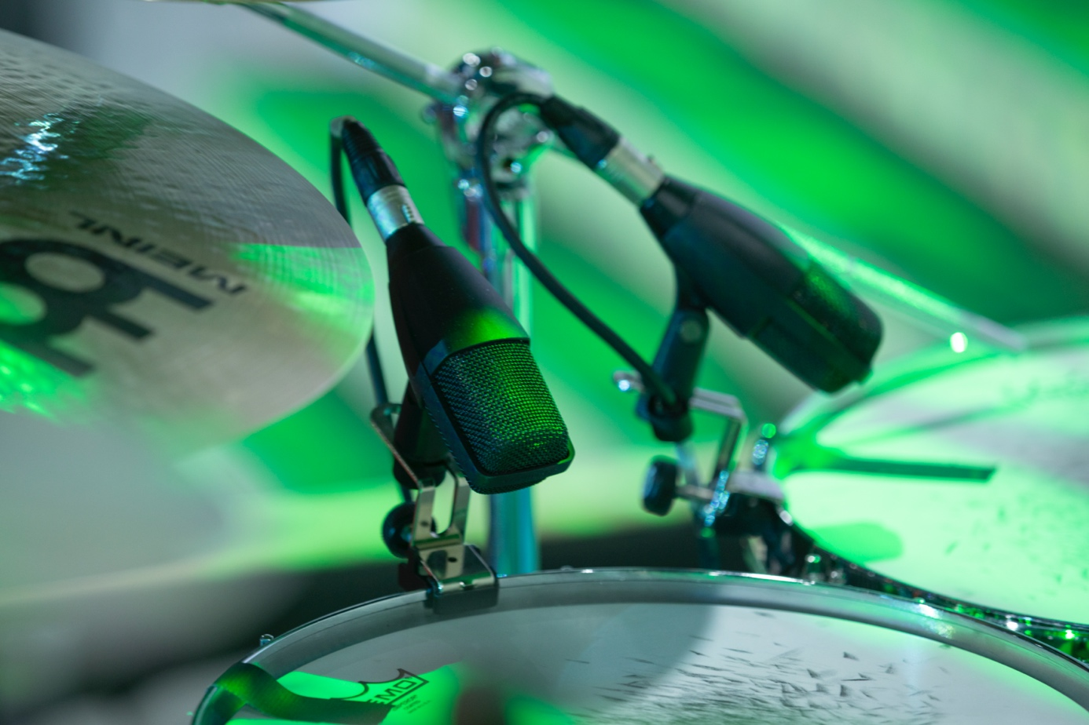 | The MD 421 Kompakt on toms  (Photo credit: Yes Music / Studio Boregard)

FoH world
FoH engineer, Andre Mussong, noted that the artists feel comfortable with Spectera: “It gives them more trust. With Spectera, artists can rely on what they hear and perform better. On the microphone side, we used Spectera for the acoustic guitar, and that worked perfectly. We are very much looking forward to getting our hands on the upcoming handheld mic. Having handhelds, instrument inputs and in-ears all in one wideband channel and one device will allow us to travel with just one 19”, 1U device to single shows. What would also be useful to have is a durable, protective SEK pouch for dancers and artists.”

“For us engineers, Spectera saves space and time,” he concludes, “and sound as well as overall performance are top notch. Spectera is an absolute new starting point for RF transmission techniques in live entertainment.”

Visit https://www.djbobo.ch/ for all tour dates.

Sennheiser wireless equipment and microphones
1 x Sennheiser Spectera Base Station with 3 x Spectera UHF DAD antenna
27 x Sennheiser Spectera SEK (26 x IEM, 1 x mic for acoustic guitar)
3 x Sennheiser EM 2050 twin receivers with 2 x Sennheiser AD 3700
6 x Sennheiser SKM 2000 handhelds with MMD 935 capsules, two standard, two decorated with black crystals, two gold-plated with gold-plated mic heads
Drums: 1 x e 901, 4 x MD 421 Kompakt, 2 x e 905, 1 x e 914, 2 x MK 4

(Ends)

The high-resolution images accompanying this media release as well as additional photos can be downloaded here. Please make sure to give the photo credits for any use of the pictures.

About the Sennheiser brand
We live and breathe audio. We are driven by the passion to create audio solutions that make a difference. Building the future of audio and bringing remarkable sound experiences to our customers – this is what the Sennheiser brand has represented for 80 years. While professional audio solutions such as microphones, meeting solutions, streaming technologies and monitoring systems are part of the business of Sennheiser electronic SE & Co. KG, the business with consumer devices such as headphones, soundbars and speech-enhanced hearables is operated by Sonova Holding AG under the license of Sennheiser.

www.sennheiser.com
www.sennheiser-hearing.com

Global Pro Audio Press Contact
Stephanie Schmidt
stephanie.schmidt@sennheiser.com
+49 5130 600-1275

